Description of the chemSpec Format
The quantum mechanical parameters of modelled chemical species are stored internally in a .json file. Each entry in the list corresponds to a single modelled entity (usually a molecule, but could be a part of it) and is characterised by the following fields:

Field | Description | Example
name | str  The name of the molecule. | “Ethanol”
chshH | list of parsSpec  Distinct proton spin chemical shift records in parsSpec format (see below). | [  [0.9, 1.1, "H1","Gaussian",0.95, 0.1, null],  [3.4, 3.6, "H2","Uniform",null, null, 3.5],  [4.7, 4.9, "H3","Uniform",null, null, null]  ]
chshC | list of parsSpec  Distinct carbon spin chemical shift records in parsSpec format (see below). | [  [18.9, 19.1, "C1","Uniform",null, null, null],  [51.9, 52.1, "C2","Uniform",null, null, null]  ]
jcplH | list of parsSpec  Distinct proton-proton J-coupling records in parsSpec format (see below). | [  [6.0, 8.0, "H1-H2","Uniform",null,null,7.0],  [4.0, 6.0, "H3-H2","Uniform",null, null,5.5]  ]
meqSpins | list of lists of two int  Each pair of numbers [chshIndx, nspin] in the list corresponds to specific group of magnetically equivalent spins (e.g. three protons in the methyl group) and encode:  indxChsh – the index of corresponding chemical shift value in the chshH array (using zero-based numbering);  nspin – number of spins in the group. | [  [0, 3],  [1, 2],  [2, 1]  ]
meqLinks | list of lists of (int and list of two int)  Correspondence between the pairs of coupled groups of spins and the specifications of J-coupling parameters from the jcplH array. Each entry in the list has the format: [jcplIndx, [spinIndexA, spinIndxB]], where:  jcplIndx – the positional index of the J-coupling parameter characteristics in the jcplH array;  spinIndxA, spinIndxB – positional indices of the groups of coupled spins in the meqSpins array. | [  [0, [0, 1]],  [1, [1, 2]]  ]
multH (optional) | list of int  Multiplicities of each spin system in the molecule (optional, default multH = [1]). If the molecule contains several equivalent spin systems with the same topology and parameter values, they need to be specified only once with meqSpins and meqLinks arrays; the number in multH needs to be set to the desired count of spin systems (e.g citric acid). The positional order of spin systems is inferred from the order of spins in the meqSpins array. | [1]
multC (optional) | list of int  Multiplicities of carbon spins with the same chemical shift parameters; typically – a list of ones with the length (and the positional order) related to chshC. However, in symmetric molecules, several carbons may have equal chemical shifts, and setting their multC accordingly allows one to control the relative intensities of the corresponding peaks. | [1, 1]

If only proton spectra are of interest, chshC and multC fields can be omitted. Similarly, if the molecule does not contain coupled protons, jcplH, meqSpins, and meqLinks are not necessary.
All chemical shift and J-coupling parameters are specified separately with a unified format, parsSpec, which in the .json file takes the form of a list:
[min, max, label, distr, p1, p2, dval]
min, max | float  Minimum and maximum values of the parameter.
label | str  The label displayed in the table of parameters.
distr | str  Name of the prior distribution: “Uniform”, “Gaussian”, “Constant”, “Exponential”
p1, p2 | float  Parameters of the prior distribution, if any (e.g. for Gaussian p1-mean, p2-standard deviation).
dval | float  Default value of the parameter; if null, will be set as (min+max)/2.

Extending the List of Chemical Species

There are a number of most common chemical species already available in the nmrQuant software. Other species of interest can be easily added using their specification in .mol (.sdf) files; the missing NMR parameters (chemical shifts and J-coupling) can be approximated using a convenient on-line tool found at nmrdb.org. The following steps describe a typical procedure for adding a new chemical to the list of available species.

- Obtain a .mol (or .sdf) file describing the list of atoms and bonds. Only the backbone atoms need to be specified (any missing hydrogens will be added according to the standard valence; currently only C, N, and O atoms in the backbone are supported). Such file can be obtained from chemical database (e.g. PubChem, HMDB, Chemspider, etc.); only a single molecules per file is currently supported. There are no restrictions on using 2D or 3D conformers.

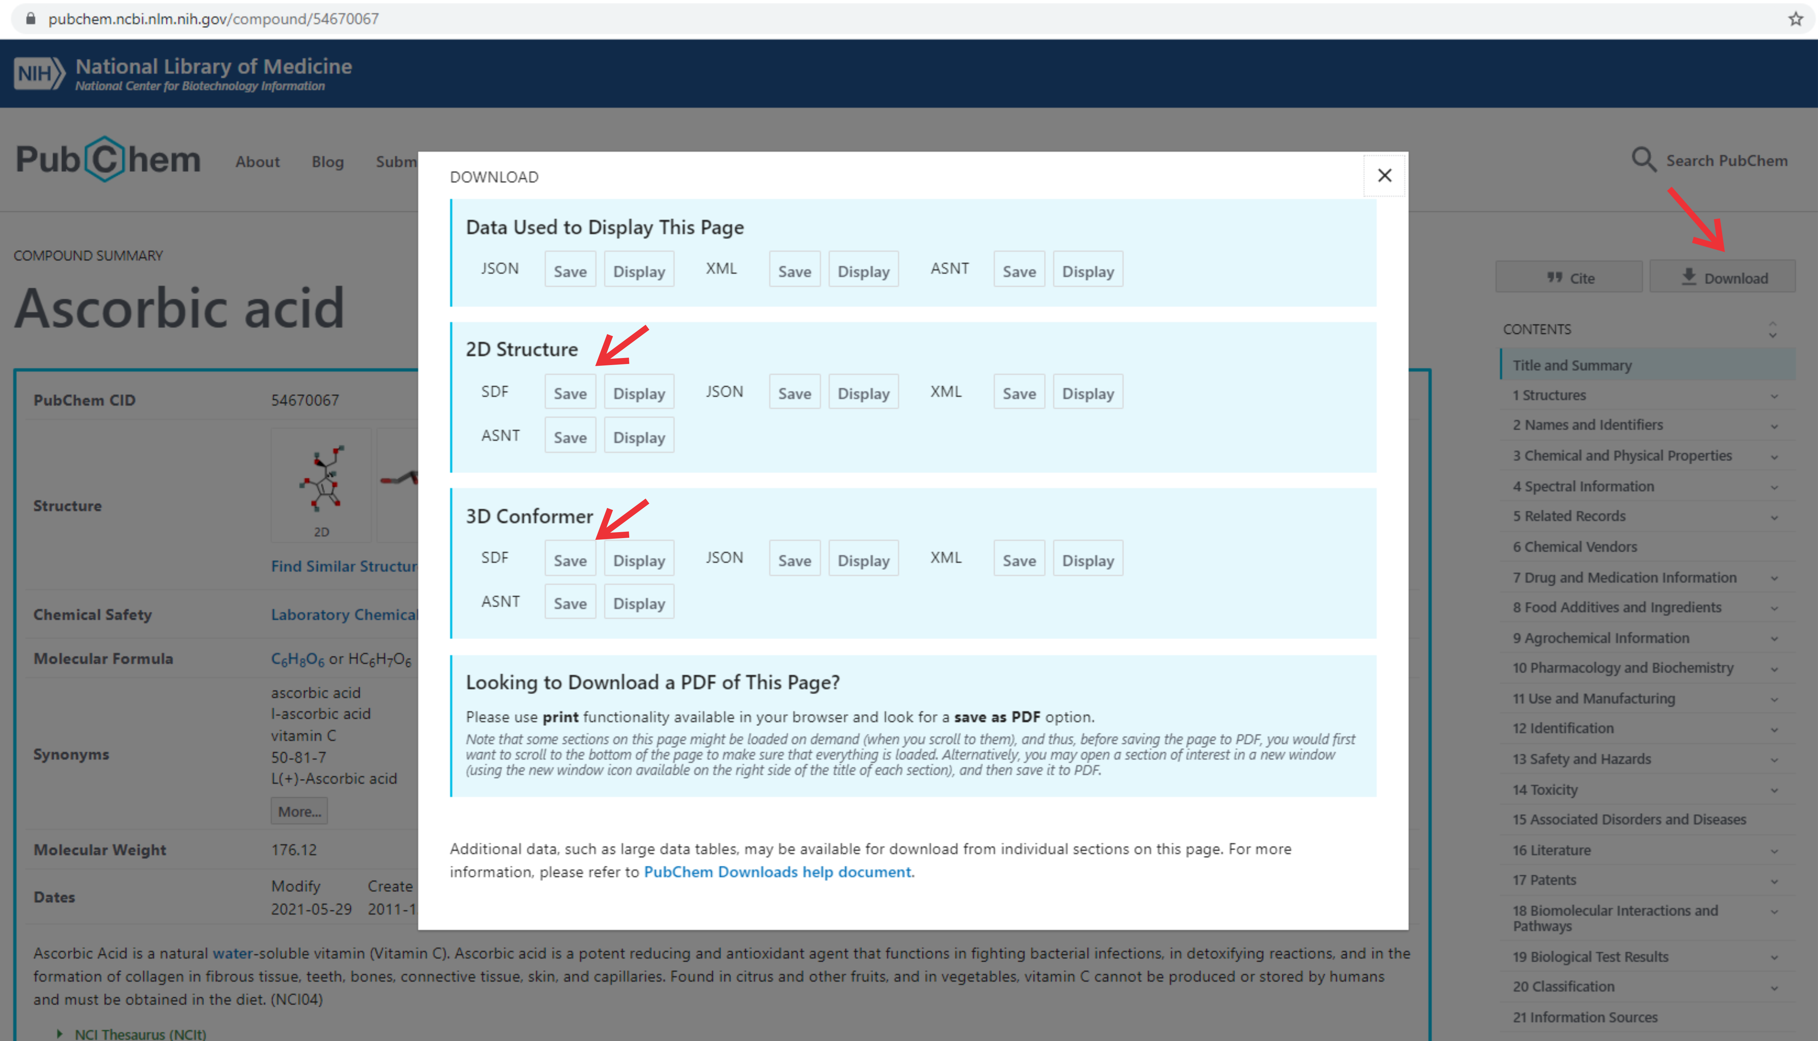

- Upload the obtained .mol or .sdf file to the NMR predictor at https://www.nmrdb.org/new_predictor/ and click “Simulate spectrum”. Alternatively, one can use SMILES format to specify the desired molecule or draw it directly on the nmrdb.org page; in this case, it is necessary to save the resulting .mol file by selecting “Download All” or copying it to clipboard and creating the file manually.

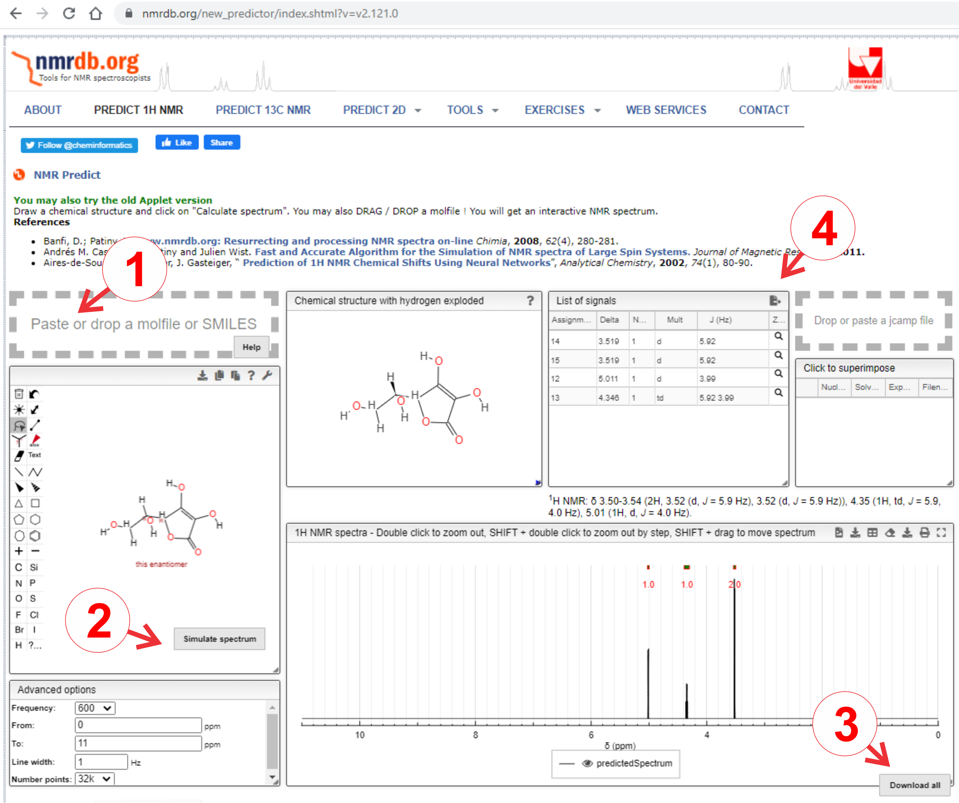

- Once the NMR simulation has finished, the predicted chemical shift and J-coupling values should appear in the “List of Signals” table. In the table header, select “Export data” and copy the entire table as text.

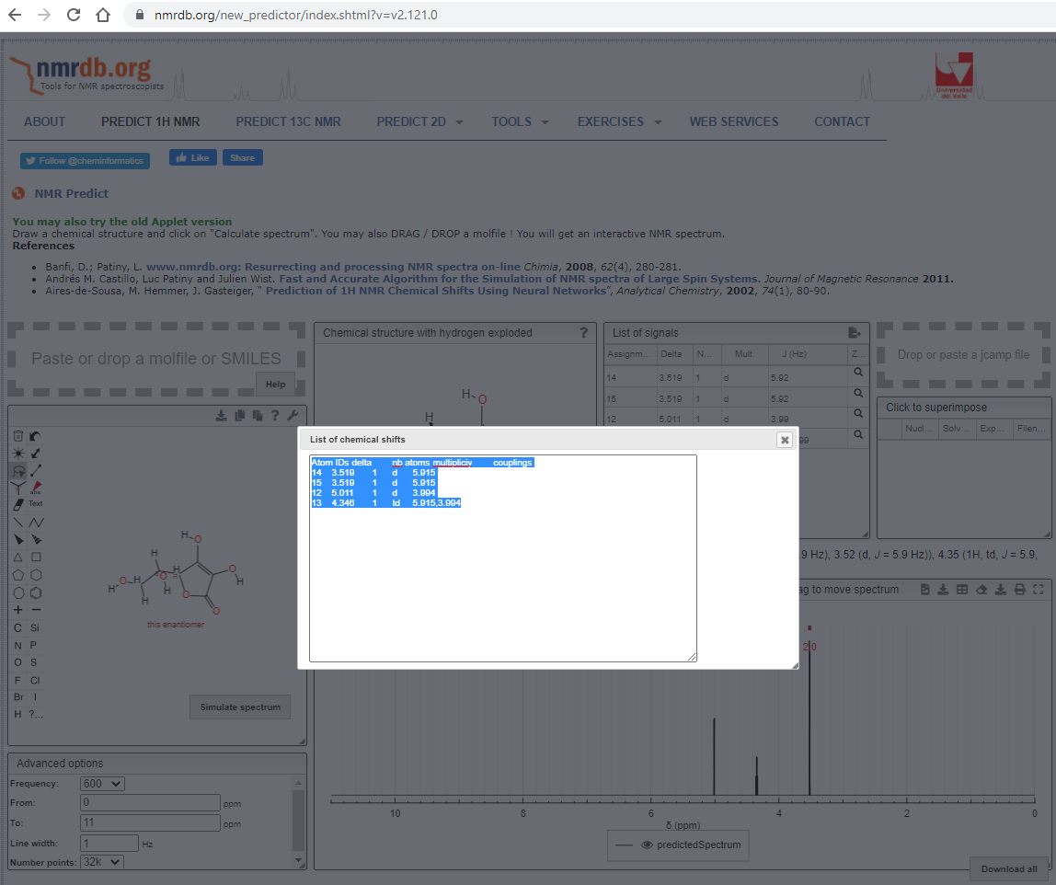

- Open the .mol (.sdf) file in a text editor and insert the copied table of NMR parameters. For this, anywhere after the mol block (after the last ‘M END’ line but before the final line, ‘$$$$’), create a new data entry starting with
> <NMRDB-H>
and paste the copied table on the next line. Make sure that the first line in the file contains the desired chemical name (otherwise, it will be inferred from the file name) and that the fourth line contains the MDL .mol header with specification of the file version (V2000 or V3000) as the last five characters.

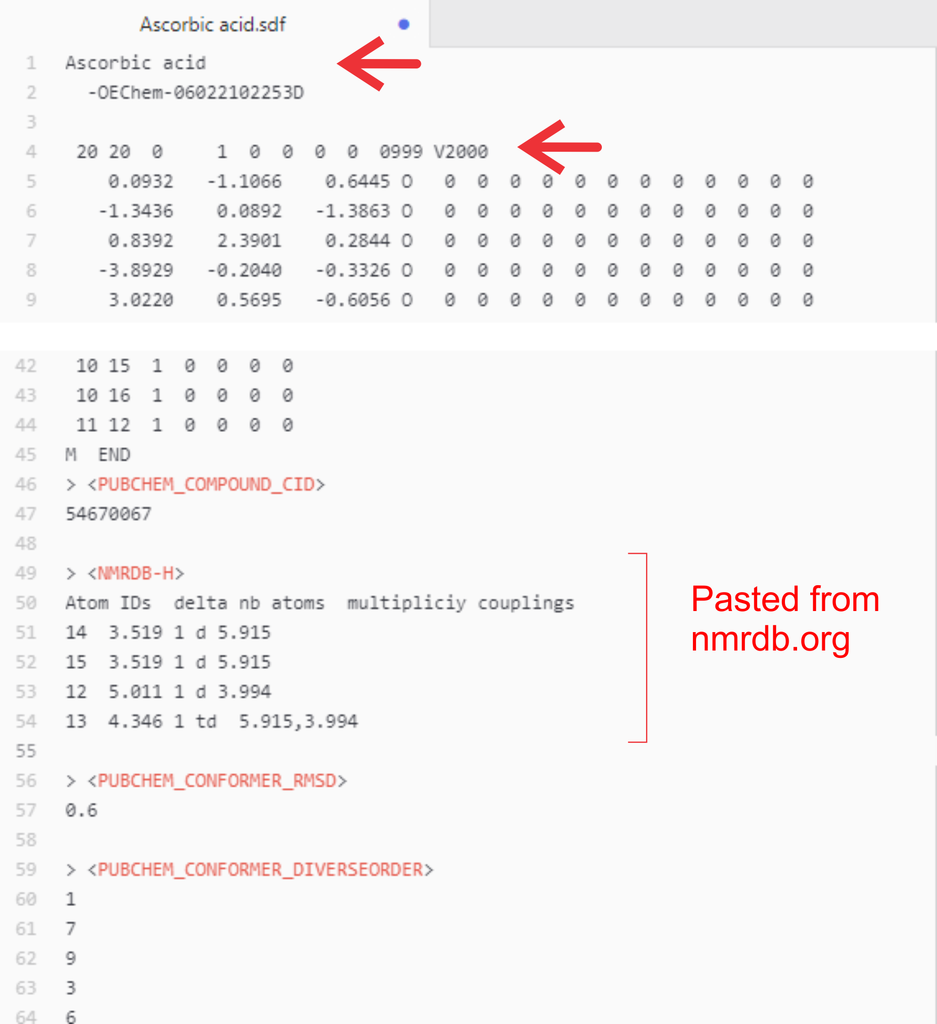

- Save the modified .mol (.sdf) file in the ../chemdb folder found in the root directory of the nmrQuant software. If desired, several files can be grouped in a subfolder within the chemdb folder, which may facilitate their selection in the nmrQuant GUI.
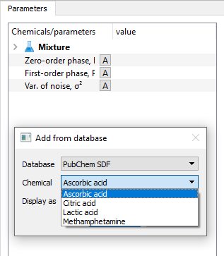

- The entire library of chemicals defined in the system (includeing those imported from .mol/.sdf files) can be saved as an Excel spreadsheet using the following command:
writeChemLib_XLSX(chemLib, 'chemLibrary_saved.xlsx').

